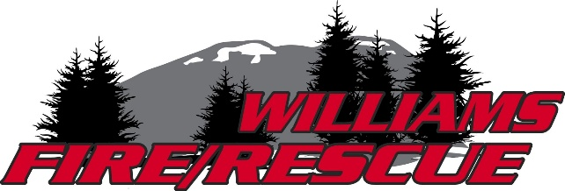

WILLIAMS RURAL FIRE PROTECTION DISTRICT
REGULAR BOARD MEETING AGENDA

Tuesday, August 11th, 2026
Place and Time: District Headquarters, 211 E. Fork Road, Williams OR, at 10:00 AM
Join Zoom Meeting
https://us06web.zoom.us/j/5918971593?pwd=vlfa5CsLauwJNJfAcwG3SyWZjFgTYS.1
Meeting ID: 591 897 1593
Passcode: 8467644

- Call to Order, Pledge, and Roll Call of Members
- Announcements
- Approval of Prior Board Meeting Minutes – previously distributed electronically
-June 25, 2026 Regular Board Meeting Minutes
-July 9, 2026 Board Meeting Work Session Minutes
-July 14, 2026 Regular Board Meeting Minutes

- Clerk Treasurers Report – Financial Reports
  - June 2026 financials tabled at last board meeting
  - July 2026 Financials
- Reports
  - Fire Chief’s Report
  - Operation Chief’s Report
  - District Fire Marshal Report / Safety Committee Report
  - Community Relations Coordinator Report
  - WFA Report / Community Woodbank
  - Chair Report

- Unfinished Business
  - Paid Leave policy follow-up
  - Internal Controls
    - Door Lock keypad installation on Offices and Modular Home
    - District Credit Cards conversation: Deployment and Staff Cards
  - Policy Manual Framework

- Tabled Unfinished Business
  - Station Decontamination Showers
  - Museum Building/Bldg. 7/8
  - Solar Project – Feasibility Study with Oregon Clean Power Cooperative

- New Business
  - MOU for Equipment – Shared Resources

- Announcement of the next regular scheduled board meeting – Tuesday, September 8, 2026 at 10:00am
- Public Input – two minutes at end of meeting
- Public Questions – can be submitted in writing to PO Box 81, Williams, Oregon 97544
- Motion to adjourn
Posted in accordance with ORS 192.640 - Heather Glass, Board Chair, Williams Rural Fire Protection District Board of Directors

